# Data Source

In India, the Criminal Procedure Code divides crimes into two heads: cognizable and non- cognizable. The police have the responsibility to take prompt action on receipt of a complaint or of credible information in the case of cognizable crimes. Cognizable crimes are again sub-divided as those falling under either the Indian Penal Code (IPC), or under the Special and Local Laws (SLL). Non-cognizable crimes, on the other hand, are left to be pursued by the affected parties themselves in Courts. The police force initiates investigation into such crimes except with magisterial permission. In India statistics on crime are published annually by the **National Crime Records Bureau,** under the **Ministry of Home Affairs**. State, City and district wise data is available on number of different crimes committed, judicial institutions and enforcement mechanism in a standardized format. 'Crime in India' was first brought out 1954. Since then it is being regularly published. The focus of this study will be only on IPC crimes **(cognizable crime)**. The reason is that the motivations and enforcement mechanism for SLL crimes are different from that of IPC crimes.The study is restricted on 16 major states because of non-availability of data.

# Methodology

Firstly, annual crime incidence have been taken for the years 1991 to 2011. Based on these

crime incidences, linear graph has been constructed to see the trend. Secondly, in order to find out changes in the composition of crime, crime rates for different heads of crime at three different points of time i.e. 1991, 2001 and 2011 is calculated. For the same time periods crime heads as percentage to total crime are also represented in the form of tables.

# Composition of crime (1991, 2001 and 2011)

The composition of crime in a region or state becomes part of the basic exercise in the study of crime. This section aims to finding out the composition of crime in India and to highlight the changes taken therein from 1991 to 2011.

# Table: 3.1 Percentage (per cent) Contribution of Different Crime Heads in Total Crime

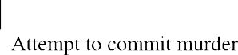

|  |  |  |  |
| --- | --- | --- | --- |
|  |  |  |  |
|  |  |  |  |
|  |  |  |  |
|  |  |  |  |
|  |  |  |  |
|  |  |  |  |
|  |  |  |  |
|  |  |  |  |
|  |  |  |  |
|  |  |  |  |
|  |  |  |  |
|  |  |  |  |
|  |  |  |  |
|  |  |  |  |
|  |  |  |  |
|  |  |  |  |
|  |  |  |  |
|  |  |  |  |



Table 3.1 shows different crime heads as a % to total crime from 1991 to 2011. In 1991, theft alone had highest percentage (21.6%). And, preparation & assembly for dacoity shares the lowest % (0.1);whereas in 2001,major crime heads retain their position. Again, theft is found sharing highest percentage (14.3%) but lowest percentage (0.1%) here is being shared by counterfeiting (0.1%). However, in 2011, again theft had highest percentage (14.7%) and preparation & assembly for dacoity and counterfeiting shares the lowest % (0.1).

Changes in the composition of crime are apparent (table 3.1) .In 1991, the total incidence of IPC crime in India was 16,78, 375 which increased to 17, 69, 308 crimes in 2001. Therefore, the decadal growth becomes 5.4% and average annual rate comes to 0.8%. In terms of %, dominance of crimes against property which include theft, robbery, burglary, and dacoity is evident at all points of time. Nonetheless, their % has declined considerably (from 31.8% in 1991 to 21.5% in 2001). This change may be attributed to the growth of other crimes. In fact, rapes and cheating have almost doubled in these years and kidnapping & abduction have increased due to rise in the incidence in India. However, murder and counterfeiting seem to have gradually declined. Though, there is a decline in the percentage of riots in 2001 (4.3%) compared to 1991 (6.3%).There is also a rise in the % of others crime from 52.8% (1991) to 64.4% (2001). This increase shows the decline in the % of other crime in this decade.

The different pictures comes when we compare next decade i.e. 2001and 2011. In these years, total incidence of IPC crime has also gone up from 17, 69,308 in 2001 to 23 25,575 in 2011.The decadal growth becomes 31.4% and average annual rate was 3.0%. This represents a massive increase in the growth of this decade because in the earlier decade (1991-2001) it was only 5.4% which was much lower than the current decade (2001-2011).In term of %, same scenario has come up in this decade. Crime against property which include theft, preparation & assembly for dacoity, robbery, burglary, and dacoity have declined from 21.5% in 2001 to 20.0%, but this decline is very small only 0.5%. There is sharp decline in the murder from 2.0% (2001) to 1.5% (2011) and riots from 4.3% to 2.9%. There are gradually increase in the % of rape and kidnapping and abduction from 0.9% and 1.3% to 1.0% and 1.9% respectively in this decade. The main point to note here is that the % of kidnapping and abduction of women & girls have almost double. Crime against women has also gone up in these years.

# Trends of Crime Rate

**Figure: 3.1 Trend of Crime rate (IPC) in India (1953 to 2011)**

250

200

150

100

50

0

crime rate

Source: national crime records bureau.

1950

1953

1956

1959

1962

1965

1968

1971

1974

1977

1980

1983

1986

1989

1992

1995

1998

2001

2004

2007

2010

Analysis of crime-rates (at national level) for the last two decades does not show a smooth trend. Figure 3.1 represents the smooth picture of total crime incidences and crime rate (per 1, 00,000) of the last six decades. It showed how the pattern of crime rate has been changing from 1950 to 2011. In 1950 the rate of crime was 182.5 and total incidences of crime were 635508 in India. The crime incidences declined in 1953 from 635508 to 601964 and rate from 182.5 to 160.7 and further to 137.4 in 1955. The rate of crime was lowest in 1955 in the history of independent era of India. Why did this happen? And, what factors could have involved in this process? Such questions are important to be looked into. From 1955 to 1959 the reverse process gets in as the crime rate which was only 137. 4. In 1955 kept on rising to 147.2 in 1959. In the 1960s, a good deal of fluctuations was observed. In 1980 the crime-rate rose to 206.2 which again declined till 1987.

At the time of adoption of new economic policy 1991, the crime rate was 198.2 almost near to 200. The years become important in the 1991- 2011 decades in two ways. Firstly, it was the year having lowest crime-rate (160. 0 crimes only) in the second decade i.e. 2001-2011. Secondly, it was the year from which the crime-rate started increasing again and reached the level of almost 192.5 crimes per 1, 00,000 persons in 2011. Although it is not possible to explain such strange fluctuations but at the same time it is equally important to mark the abrupt changes after the introduction of new economic reform. Have the twin

processes of industrialization - urbanization led to overall increase in crime? Or it is growing awareness among masses responsible for a comparatively higher reporting of crimes because of the education? Have our social-priorities and cultural goals become dominant over the 'sanctioned - means' to achieve them? Also, it is important to find out is the basic needs of human being one of the factor of rising crime in this decades? Sometime people choose illegal activities rather than legal activities because of fewer opportunities in the economy. It is important to know about the state level pattern of the some important crime in which study will focus on like murder, rape, kidnapping & abduction and burglary.

# Contribution in total IPC crime at State level

The following Table 3.2 tell us the contribution (in %) of IPC crime of sixteen major state in all India IPC crime, it shows the contribution of a state in total IPC crime and their changing contribution with the time period from 1991 to 2011. The idea behind this table is that it will give us a clear pattern of crime contribution of different states in total all India IPC during the liberalization era. Before going on state wise explanation of different major crime heads it is important to know about the state wise contribution of IPC crime in total crime in India and this contribution includes all the IPC crime heads. In this table, the following years have been taken; 1991, 2001 and 2011, because it represent decadal trends and is simple to understand and more comparable.

# Table: 3.2 Percentage contributions to all India total (IPC crime)

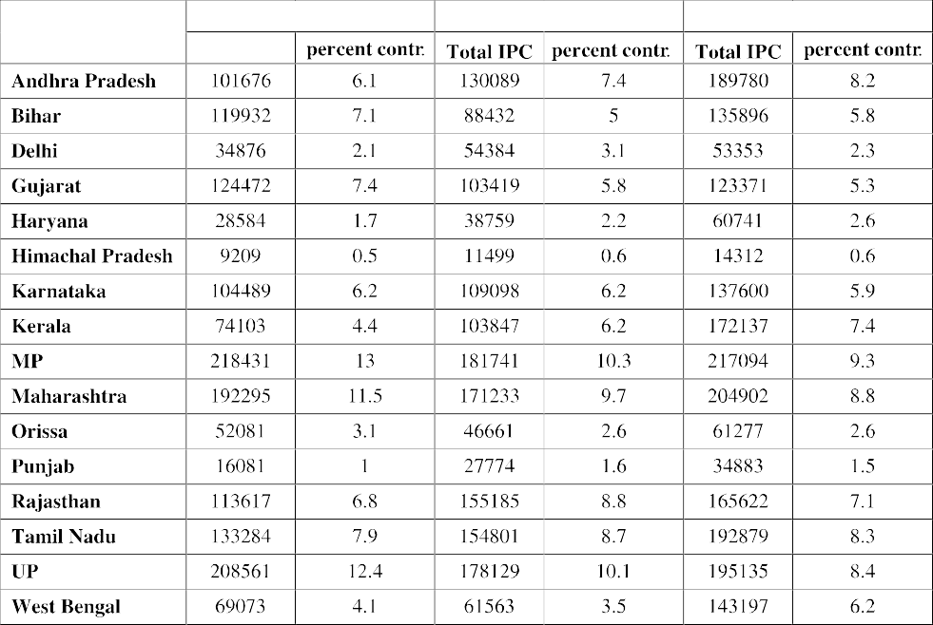



As depicted in the above table, in 1991, Madhya Pradesh was the highest % contributed state in all India IPC crime. MP has shown highest incidence (218431) and 13% contribution in total IPC. The second highest contributed state was Uttar Pradesh (UP), having 12.4% contribution with 208561total incidences. The lowest contributed states were Himachal Pradesh and Punjab. The state which lies in southern part of India also contributed one fourth of total IPC crime together. On the other hand, the states on the northern part of India like Haryana, Delhi and Bihar have contributed 1.7%, 2.1% and 7.1%. The total contribution of Gujarat and Rajasthan which are the western part of India in all IPC crime was 14.2%.The eastern part of India, state like Orissa and West Bengal contributed 3.1% and 4.1% respectively. Thus, overall the major contribution of IPC crime in all total India were came from those states which are the central part of India.

In 2001, some major decline and increase were found in the contribution of IPC crime of some states. Again, Madhya Pradesh shown highest contribution in all India; Uttar Pradesh and Maharashtra have also shown declining trend in their contribution. Bihar, Gujarat, Orissa and West Bengal have also shown a declined contribution in all India. On the other side some states like Kerala, Tamil Nadu, Rajasthan, Delhi, Haryana and Karnataka have shown rising trend in contribution as compared to 1991.

However in 2011, MP, Maharashtra and UP have shown continually decline share of contribution in total IPC crime in India.MP still has larger contribution in India's total crime but its declined from last two decadal. Only Bihar and West Bengal have shown upward trend from 2001 to 2011. The same trend, which was found in 1991 to 2001 of other states, has shown in 2011.The contribution of Andhra Pradesh, Haryana and Kerala were further increased in 2011. On the other hand, the contribution of following states has significantly declined in 2011 named by Gujarat, Karnataka and Orissa. Some states like Delhi, Punjab and Rajasthan were shown upward trend from 1991 to 2001 and have shown downward trend of contribution from 2001 to 2011.

# State wise contributions (per cent) in different Crime Heads

Table (3.4) represent the state wise contribution (in %) of murder in all India (total murder). This table gives state wise decadal trend of murder from 1991 to 2011 and has also explained how the pattern of murder has been changing within states over the decades.

# Table: 3.3 State Wise Percentage Contribution in All India Murder Crime

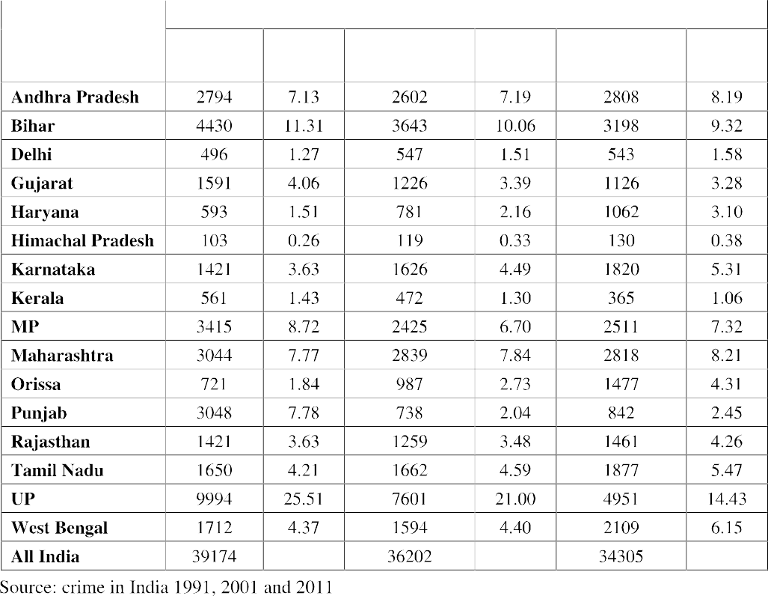

**Figure: 3.2 State wise contribution (in per cent) in total Murder Crime**

4% 5% 7%

11%

1%

26%

2

0

9%

1%

4% 4% 8%

8%

2%

**1991**

AP

Haryana MP

Rajasthan others

Bihar Delhi

HP Karnataka

Maharashtra Orissa Tamil Nadu UP

Gujarat

Kerala Punjab WB

4%

%

% 4%



**2001**

7%

17%

10%

2%

4%

3%

2%

0%

4%

21%

7%

1%

8%

5% 3%

2%

3%

**2011**

15%

8%

9%

2%

6%

3%

3%

0%

14%

5%

7%

1%

5%

8%

4%

4%

2%

Source: crime in India 1991, 2001 and 2011.

In 1991, the total incidence of murder in India was observed 39174. From the sixteen states, Uttar Pradesh was reported highest incidence of murder (9994) and its contribution in the total murder was 25.5%. The lowest contributed state was Himachal Pradesh (0.26%) and reported only (103) incidence of murder. One fourth of all murder in India was accounted for by the Uttar Pradesh and more than half of all murder in India was accounted for by the four states UP (25%), Bihar (11%), MP (9%) and Maharashtra (8%). Most of the murder was accounted by the central and east (Bihar) part of India.

In 2001, the total incidence of murder was 36202 in India which shows a sharp decline in the murder. Again the highest contributed state in all India murder was UP (21%) and the lowest share contributed state was Himachal Pradesh (0.33%). Those states whose shares were declining from 1991 to 2001 are Gujarat, Kerala, MP, Punjab, and Bihar. Although some states shown larger share in 2001 as compare to 1991 named as Andhra Pradesh, Delhi, Haryana, HP, Karnataka, Orissa, Tamil Nadu and West Bengal.

In 2011, the number of murder was declined from 36202 in 2001 to 34305 in 2011. Moreover, there was a sharp decline in murder incidence in India from 1991 to 2011. Though the dominated state was UP in the share contribution but a major decline in share was found in the UP on the; other hand, share of Andhra Pradesh, Haryana, Orissa, Maharashtra and West Bengal were gone up. Surprisingly, different picture has emerged in 2011 as compared to 1991 and 2001. The new states have emerged with larger share in the all India murder as before mention as their name by Delhi, Karnataka, Rajasthan, West

Bengal and Tamil Nadu. These states were shown continuously upward trend of their share in total murder.

# Table: 3.4 State Wise Percentage Contribution in All India Rape Crime

|  |  |  |  |  |  |  |
| --- | --- | --- | --- | --- | --- | --- |
|  |  | | | | | |
|  |  |  |  |  |  |
|  |  |  |  |  |  |  |
|  |  |  |  |  |  |  |
|  |  |  |  |  |  |  |
|  |  |  |  |  |  |  |
|  |  |  |  |  |  |  |
|  |  |  |  |  |  |  |
|  |  |  |  |  |  |  |
|  |  |  |  |  |  |  |
|  |  |  |  |  |  |  |
|  |  |  |  |  |  |  |
|  |  |  |  |  |  |  |
|  |  |  |  |  |  |  |
|  |  |  |  |  |  |  |
|  |  |  |  |  |  |  |
|  |  |  |  |  |  |  |
|  |  |  |  |  |  |  |
|  |  |  |  |  |  |  |



Table (3.4) shows us the state wise incidence of rape and the % share of the states in total rape incidence in India. In 1991, the total incidence of rape was (10410) reported in India. The highest rape incidences were observed in Madhya Pradesh (2596) i.e. 25% in all India total rape incidence. The state which follows MP was Uttar Pradesh. The lowest contribution in total rape cases in India done by Punjab (0.61%) and followed by Himachal Pradesh (0.87%).

In 2001, there was major rise in total incidences of rape in India (16075). Again MP has contributed (18%) in total India but there was decline in the share % in total. The state which was reported lower incidence of rape in India was Himachal Pradesh (124) followed by Gujarat (286). There was major decline in the per cent share in total India of some states namely were Gujarat, Bihar, Maharashtra, Rajasthan, Tamil Nadu, UP and West Bengal. But from the above state, only in Gujarat the incidence of rape has declined (not major fall) from (304 to 286) otherwise rest of the states were shown upward trend in this decade (1991-2001). Again, most of the incidences of rape were observed in the central and western part of India.

# Figure: 3.3 State wise contribution (in per cent) in Rape Crime

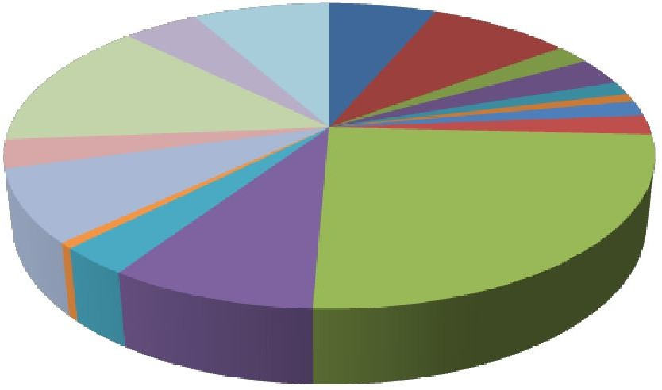

Andhra Pradesh

Gujarat Karnataka Maharashtra

**1991**

Bihar Haryana Kerala Orissa

Delhi

Himachal Pradesh MP

Punjab

5%

8% 6%

8%

2% 3%

1%

1%

14%

2%

2%

8%

3%

25%

9%

1%

3%

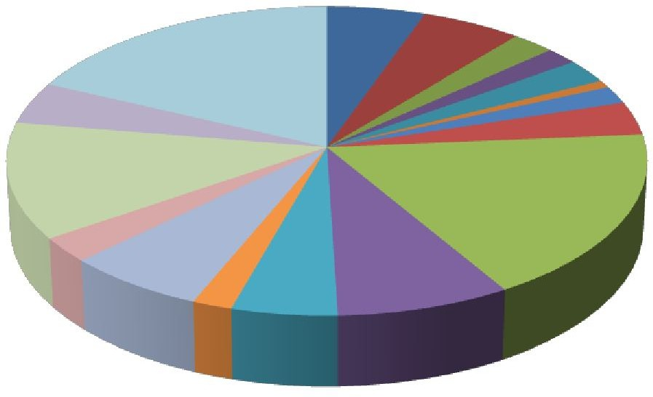

**2001**

2%

4%

18%

5%

6%

2%

1%

2%

2%

12%

4%

18%

7%

5% 8%

3%

2%

**2011**

4% 2%

19%

6%

10%

8%

2%

3%1%

3%

5%

14%

7%

5%

7%

3%

2%

Source: crime in India 1991, 2001 and 2011.

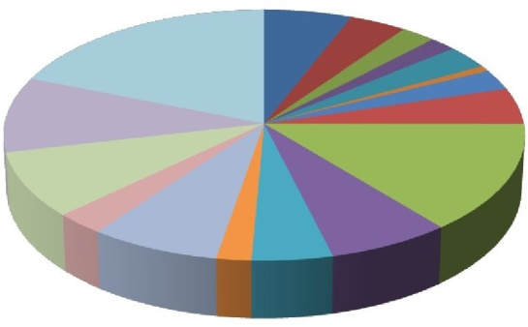However, in 2011 the total incidences of rapes were reported in India was 24602 which was higher than from 2001. The lowest contributed state in total was Himachal Pradesh (0.69%). The major increase was observed in West Bengal where the total incidence was 2363 recorded in 2011. On the other hand, contribution of UP and MP in total has declined but it shows upward trend of rape incidence from l991 to 2011. Overall the data of all three years has shown that the crimes against women have increased over the years; where most of the rape cases accounted in central, eastern and western part of India from last two decades.

# Table: 3.5 State Wise Percentage Contribution in All India Kidnapping & Abduction

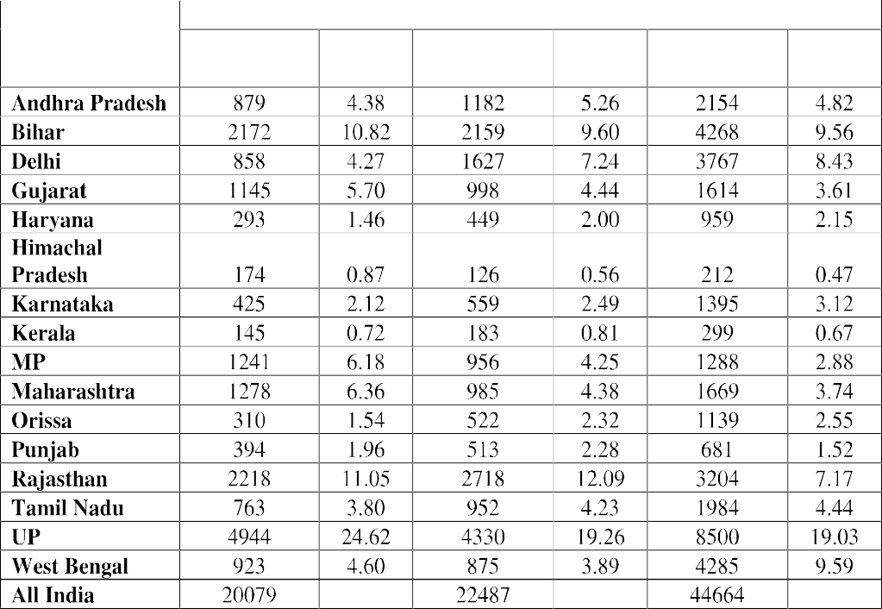

**Figure: 3.4 State wise contribution (in per cent) in Kidnapping & Abduction**

**1991**

AP

Haryana MP

Bihar

HP

Maharashtra

Delhi

Karnataka Orissa

Gujarat

Kerala Punjab

5%

10% 4%

11%

4%

6%

25%

1%

2% 1%

6%

6%

11%

1%

4%

2% 2%

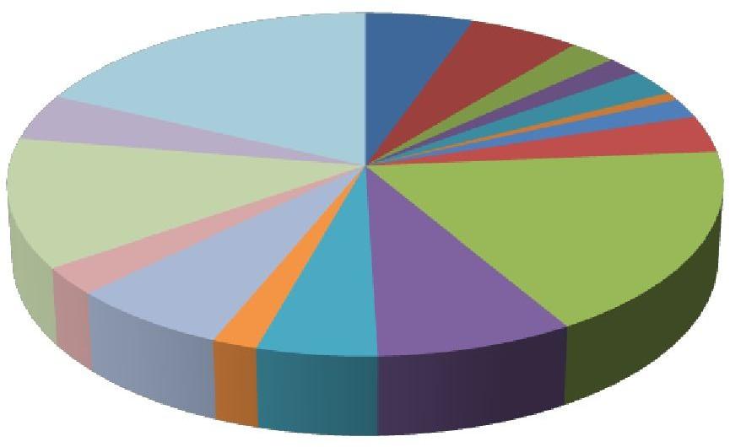

**2001**

6%

4%

18%

5%

2% 2%

2%1%

2%

4%

12%

18%

7%

3%

5% 8%

2%

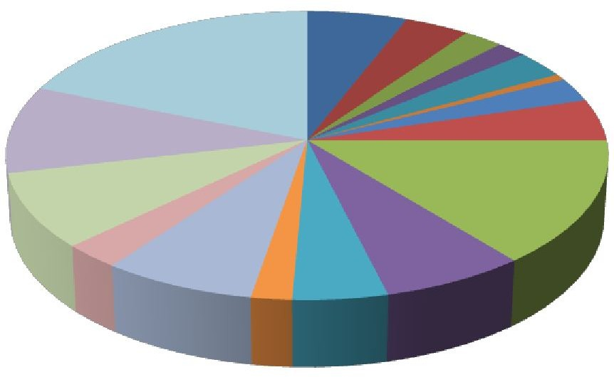

19%

6%

4% 2%2%

10%

3%

1%

3%

5%

8%

14%

7%

5%

7%

3%

Source: crime in India 1991, 2001 and 2011.

**2011**

2%

Table (3.5) represents the state wise incidence of the Kidnapping & Abduction of decadal years (1991, 2001 and 2011). The total incidence of K & A were reported in 1991 was 20079 in India. From among the sixteen states, UP has the largest contribution; one fourth

% share of K &A in total India were accounted by UP. The lowest contributed state was Kerala. The most of the incidence of K & A were reported in the central, western and eastern regions of India. The southern region has shown smallest share in all India total.

In 2001, the incidence of K & A has increased from 20079 in 1991 to 22487 in 2001. Himachal Pradesh has contributed smallest with some states namely Bihar, Gujarat, HP, MP, Maharashtra, UP and West Bengal have shown declining trend of K & A (incidence) in this decade. UP has shown largest contribution in all India in 2001 which is quite low as compare to 1991. A sharp increase in the incidence of K & A in the following states mainly in Andhra Pradesh, Delhi, Haryana, Orissa, Punjab, Rajasthan and Tamil Nadu. The majority of this crime came from the central, eastern and north-west part of India.

In 2011, the total incidence of K & A observed in India was 44664. These incidences were twice from the year of 1991. The most important state for observing was Delhi, the incidence of K & A risen very fast during the decades. In West Bengal and Bihar, there was huge jump in the reported cases of K & A in the year of 2011 as compare to other. These two states contributed almost 21% share together in total all India. Again UP was the top and HP was bottom in the share list. The states whose share has been increased from last two decades were Delhi, Haryana, Karnataka, Orissa and Tamil Nadu.

# Table: 3.6 State Wise Percentage Contributions in All India Property Crime

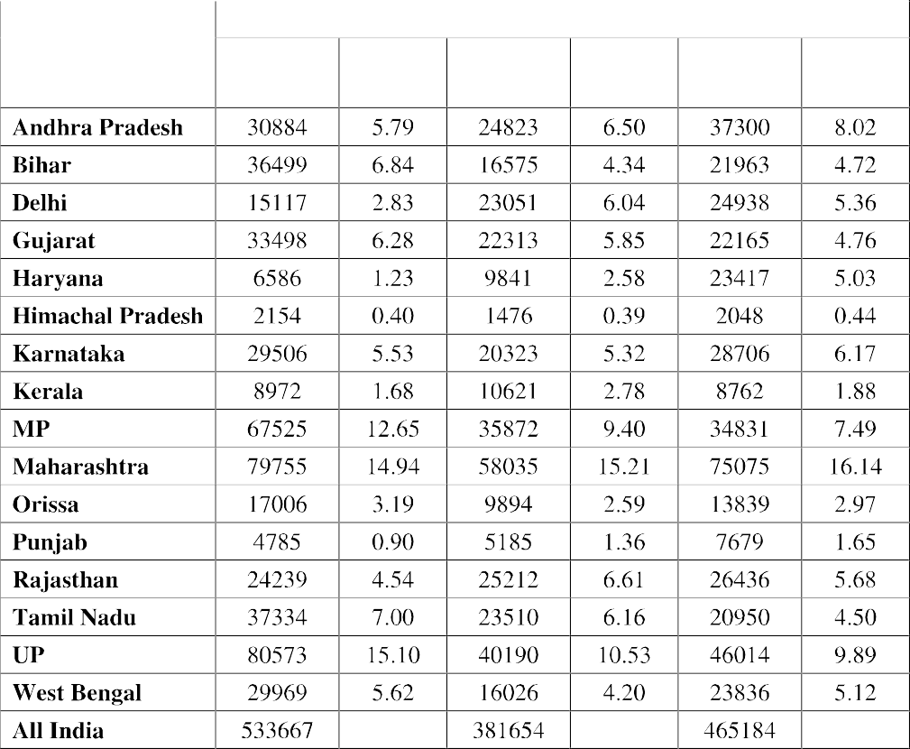

Table (3.6) represents the property crime of the India states and their contribution in the all India property crime of three years i.e. 1991, 2001 and 2011. In 1991, total crimes against property observed in India were 533667. Out of this total incidence, UP has contributed largest 80573 incidences and its share in percentage was 15.1% in 1991. Altogether Maharashtra, MP and Uttar Pradesh were contributed more than two third share of India's total. Thus, majority of the property crimes in India came from the central region in 1991.

In 2001, there was decline in total incidence of crimes against property from 533667 in 1991 to 381654 in 2001. There was sharp fall in the incidence of property crime in UP and Bihar. On the other hand, states like Kerala, Delhi, Haryana and Punjab where the incidence of property crime have gone up. The contribution share of Delhi was raised in this year; on the other hand % share of Bihar, Gujarat, MP, Orissa, Tamil Nadu and West Bengal have gone down. UP and Maharashtra together contributed one fourth share of total all India.

# Figure: 3.5 State wise contribution (in per cent) in Total Property crimes

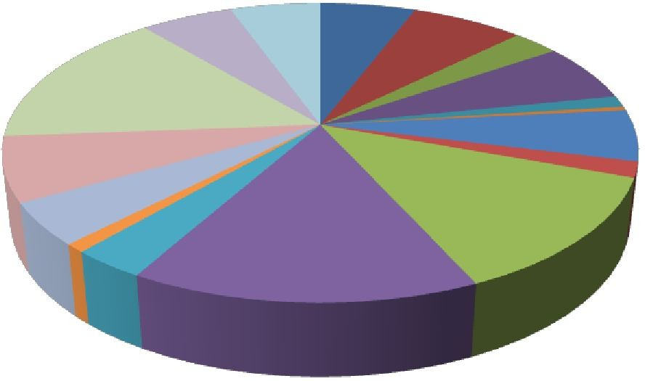

**1991**

AP

Haryana

MP

Bihar

HP

Maharashtra

Delhi

Karnataka

Orissa

Gujarat

Kerala

Punjab

6%

5% 6%

7%

15%

3%

6%

6%

1%

0%

7%

2%

13%

15%

5%

1% 3%

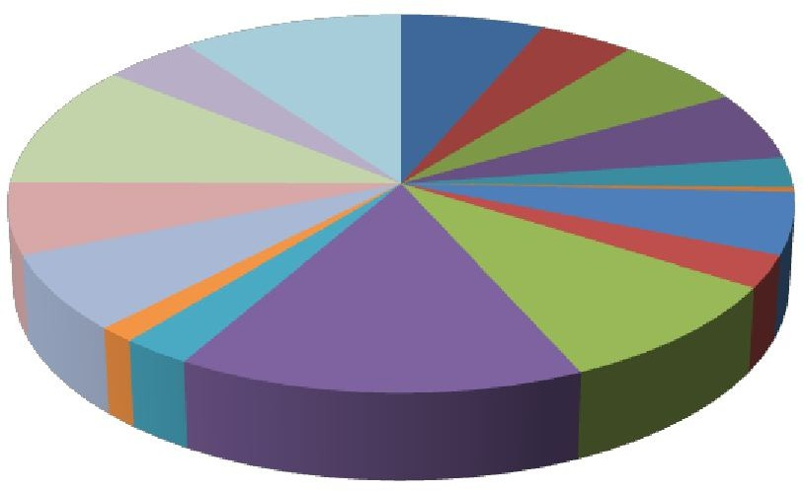

**2001**

4%

4%

10%

7%

6%

11%

6%

7%

9%

6%

3%

0%

5%

3%

15%

1% 3%

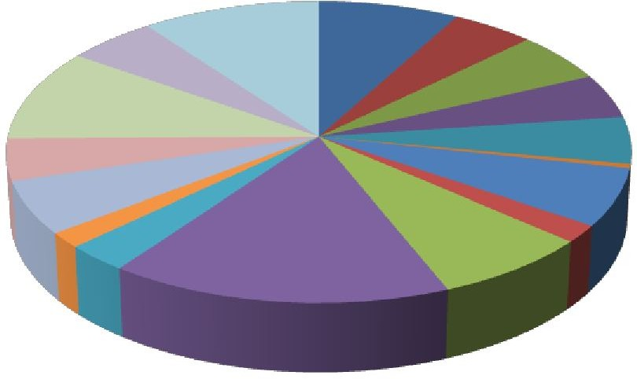

**2011**

5%

5%

10% 8%

10%

6%

5%

5%

5%

6%

5%

16%

7%

0%

2%

2% 3%

Source: crime in India 1991, 2 001 and 2011.

In 2011, the incidences of property crime in India were 465184 which were more than from 2001. Again Maharashtra has shown largest incidence of this crime and HP has lowest. But in this year newly emerged state in this crime was Haryana whose contribution has increased sharply from 1991 and 2001. The incidences of property crime have jumped from 9841 in 2001 to 23417 in 2011. Andhra Pradesh has also shown a rising trend of its contribution in total all India. Haryana was the only state where property crime has gone up very fast over the last ten years.

# Relationship of Crime and Social indicators

It is important to find out how much socio economic variables impacts the crime in the

economy. Are these socio economic variables determining the crime in the society? Do these variables contribute any role in the determination of crime rate in the economy or is there any relationship between these variables and the different crime heads in India? The answer of these questions is very important.

# Table: 3.7 Relation of crime rate with socio-economic variables



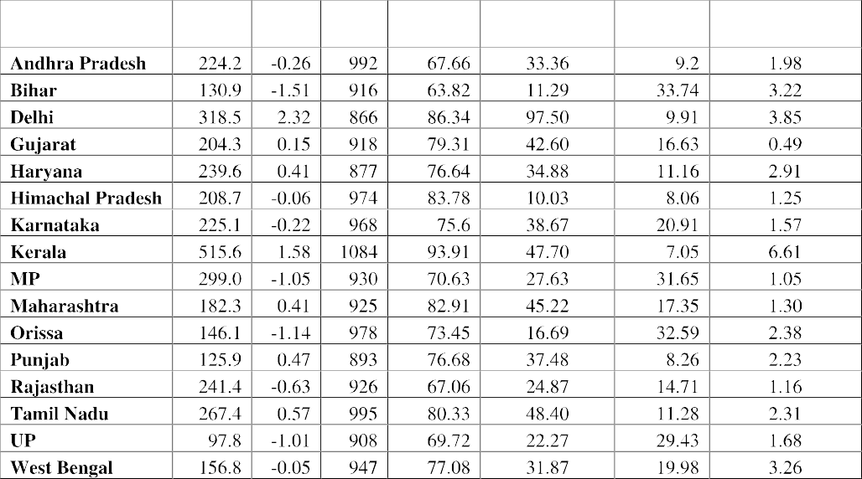

Table 3.7 represents the overall picture about the relation of selected crime heads with selected socioeconomic variables like literacy, sex ratio, unemployment rate, urbanization rate and poverty (percentage of poor in total population). This table mention the index value of the entire socioeconomic variables because it will help us to known about the degree of impact of all socioeconomic variables together on crime rate in India and also provide a better picture about the relationship between socioeconomic variables and the crime in India. The highest value of index found in Delhi (i.e. 2.32) and crime rate (number of crimes committed per 1, 00,000 population) of this state was 318.5 which were second highest among the sixteen states. The rate of Kidnapping & Abduction and Property crimes were highest in the state of Delhi. This is shows us that socioeconomic variable has a strong effect on the crime. Among the states, Delhi has most urbanization state but the property crime in Delhi was also highest. Does this shows that more urbanization lead to more crime? Over the last decade, the rate of Kidnapping & Abduction has raised in Delhi. On the other hand, the highest crime rate was observed in Kerala and the index value of this state is (1.58) which is second highest. In this state Literacy played an important role due to more awareness among people, the number of reporting are higher in

Kerala (Even little crimes are reported in Kerala because of growing citizen rights awareness).

A study done by (Kumari, 2001), states that Kerala has a high rate of charge sheets; it lags behind India in convicting the crimes against women. When the strength of police was analyzed it was found that in Kerala policemen have to deal with more number of cases than overall in India. The high work load of the police could be one of the reasons for Kerala's lower conviction rate and better women's status with educational background, may be the reason for the high number of reported cases of crime in Kerala. The female literacy are also higher in this state which represent that awareness of female population is also higher as compared to other states where female population generally not known about their rights. That is number of reporting rape cases also higher as compared to others states. A research study conducted by Chandrika, C.S. 1998., on sexual harassment at the workplace as a part of the study for SAKSHI, an NGO in New Delhi found that 95 percent of the women felt that there was prevalence of sexual harassment at the work place in Kerala. The state like Uttar Pradesh where crime rate was observed only 97.8 per one lakh person in 2011 shows that the lowest crime state in India. This doesn't mean that crime in UP were very less but numbers of reporting were very less due to less awareness of the people. The literacy rate in UP only was 69.72 due to which people doesn't report the crime specially crime against women. The poverty and unemployment were responsible in the increasing crimes incidence in UP. Earlier tables of states contribution of different crime heads in total IPC crime in India also shown that the contribution of UP in murder and kidnapping & abduction was the highest and in other crimes not too much behind in 2011. It shows that people are more involved in illegal activities rather than legal because of lack of opportunities and also because of less awareness. Similarly in Bihar where the literacy rate was only (63 per cent) and the poor percentage was (24 per cent) in 2011 which was the lowest as compared to other states. The index has also shown that socio economic variable affects overall crimes in Bihar. The crime rate was observed 131 per lakh population in Bihar which is again least reported number of cases but again socio economic variable are responsible in determination of different crimes rate. The low level of urbanization found as per the data in Bihar and crime rate is also lower in Bihar (as compared to Delhi). Bihar contributed second highest in all India murder which shown a major part of India from where murder incidence were reported but in other crime the reporting were very less that is why crime rate were lower in Bihar. On the other hand, unemployment rate played crucial role in the determination of crime in Bihar the unemployment rate was 2.1 in 2001 and the crime rate was 106 per lakh persons but in 2011 there was major increase in the crime rate and unemployment rate (3.2) which

shows there is positive relationship between crime rate and unemployment. The lacking of opportunities pushes people into the illegal work such as kidnapping and abduction and the Property crimes like theft etc. The rate of kidnapping & abduction and theft were considerably increases over the last decade in Bihar. In Madhya Pradesh , crime rate was 299 per lakh population in 2011 and 301 in 2001 there was minor decline in rate in last decade but there was major decline found in the burglary and theft. On the other hand literacy rate has gone up from 63 per cent (2001) to 70 per cent in 2011 but there is increase in the unemployment rate from 0.9 to 1.5. The highest rape rate found in this state (4.7) which clearly shown the awareness doesn't reduce the rape incidence even in Kerala where the literacy was highest, also reported larger numbers of rape cases. It means awareness doesn't reduce the amount of rape cases. But urbanization level raises the opportunities of the illegal work; the urbanization rate in MP was 28 per cent in 2011.

Theories suggest that urbanization is good for promoting growth of industries and development in the economy. The other face of this urbanization may be the encouragement of crimes as well, since, crimes normally occur in large cities and in urbanized areas (Krivo & Peterson, 1996). In rural areas, due to lower population density, criminal persons have less chance of hiding themselves because people know each other. The opposite is true for urban areas. The main facts of crimes in urban areas are the fewer chances of arrest and recognition (Glaeser & Sacerdote, 1996). So it is argued that as urbanization increases so does crime (Galvin & Gaviria, 2002). The pattern in our study has also similar to other study where in the state like Delhi has shown higher crime rate in comparisons to UP and MP (lower urban areas).

In Gujarat, the states who have shown highest employment rate found lower crime rate as compared to other states. The literacy rate was 80 per cent in 2011 and poverty ratio was 16 per cent. The crime rate was not influenced in last decade and also shown a declining trend of different crime heads with improvement of the socio economic conditions. But state like Haryana where the murder rate was found highest (4.2) in comparison of other states, awareness doesn't too much influence the crime rate specially crime against property. The crime rate in Haryana was considerably raising even rate of selected different crime heads like murder, rape, K & A, burglary and theft also shown upward trends during last decades. But on the other hand, literacy level has gone up over the period of time. The percent contribution of property crime in total India property crimes in the last decade in Haryana was continually gone up.

In a nutshell, socio economic factors play key contributory role in explaining crime trends in India in general and across states in particular. However, it cannot be ignored that the crime figures provided by NCRB may not as close to the reality as it should be given

the nature of reporting in India. It cannot be debunked that the crimes that are most frequently occurring in our society like rape, sexual harassment etc are often seen as social stigma and hence are under reported by the victims.

# Conclusion

We can conclude that the annual crime rates are not following any specific trend line. Line graph shows there have been high irregularity and thus, a smooth curve line is not formed. What factors have given shape to such trends necessarily arouse curiosity. As far as patterns of crime rates are concerned it is difficult to present a general picture because every specific crime has its own patterns and such a condition does not allow to construct generalization, which, if drawn could give distorted imagery. Yet, specific crime wise watersheds may be identified. It is important to bear in mind that patterns show major shift during 1991 -2011. Patterns of murder suggest that the central and north central region is prone to higher rates of murder than the rest of the country. In case of rape the same pattern stands true. But, the patterns of rape rates in 1991 are totally different from 2011 patterns. Except states like Bihar, UP and Gujarat, all remaining states have shown rising trend which is important to note that what factors are responsible for upward trend of rape in Indian states. Does social factor are for this or other? K & A and property crime pattern are, on the other hand, very interesting. Why states like Delhi is showing highest rate of K & A as compare to all other states? One of the factors responsible for this rising trend may be the increasing growth of this state which led to inequalities among other state. People want to live in a state where the standard of living is high but due to less opportunities of legal work, their involvement in such kind of crime are increasing with the time period. Not even in Delhi but other states also have shown upward trend of K & A and their contribution in total India have also raised in last few years. Crimes against property patterns suggest the central and northern region have the highest rate among the all regions. Specially, northern regions are showing highest crime against property, Delhi has shown highest rate of these crimes and Haryana have shown upward trend of property crime rate from last few years. Even the murder rate has shown highest in Haryana in 2011. The study has also shown that the contribution of states in different crime heads is also raised in last few years. Among the crime heads, the number of rape cases have increased significantly because of large reporting, due to increasing awareness among women for their rights as citizen and also because of the criminal justice in India.

Moreover, it has also been observed that socio-economic variables play a crucial role in the determination of crime in India and across the states. In fact, in few states due to some social factor the variation in crime heads have been found. These descriptions and conclusions are attempted at broader level as the objective was to outline the general

image of crime in India. But certain questions are relevant to be mentioned. First, is it that all given state has similar rates? If not, why do certain states is prone to higher rates of crimes? Second, why the patterns of crime in some states have not changed even in a decade time? Does it mean that patterns of crime manifest their deep roots in social sanctions and socio-economic structure of these states? And, many more such questions need to be looked into.

The composition of crime and changes, therein support the preponderance of crimes against property in the total crime, at all points of time and gradual decline in their percentage over the years. Murder rate have also declined significantly. Rape rate and kidnapping & abduction s of women and girls has shown rising trend. Trends show great fluctuation in the patter of crime over the period of time.

The patterns at the state level show that there has been major shift in some of the crime heads from 1991 to 2011. The overall crime rate has been fluctuating during the periods but different picture come up when crime rate was taken at state level. The decadal trend of total crime in some states have shown upward trend like Andhra Pradesh, Kerala, Tamil Nadu and Haryana. The murder rate has significantly risen in Haryana and Orissa but declined in many states during the decadal period. The central region and northern region of India have found higher murder rate. At aggregate level, rape rate has shown upward trend which means crime against women has raised over the time. At state level, except UP, Bihar and Gujarat, other states have shown upward trend of rape rate. On the other hand kidnapping and abduction rate have also increased in many states but major and noticeable rise has been found in Delhi. The crime against property or total property crime has significantly declined at aggregate level and at state level but again Haryana has shown major rise in that rate.